Project title: UPI Payment and Digital Wallet System Using Interface and Exception Handling
1. Aim
To develop a Java-based UPI Payment and Digital Wallet System using interfaces and exception handling to perform wallet recharge, money transfers, and balance checking with proper validation.
2. System Requirements
Hardware requirements
- Processor: Intel i3 or equivalent
- RAM: Minimum 4 GB
- Storage: Minimum 500 MB free space
Software requirements
- Operating System: Windows/Linux
- Java Development Kit (JDK 21 or compatible version)
- IDE: Eclipse, IntelliJ IDEA, or Visual Studio Code
- Command Prompt/Terminal for compilation and execution
3. Algorithm / Logic
- Start the program.
- Define a Payment interface with methods for making payments and checking balance.
- Create a DigitalWallet class that implements the Payment interface.
- Initialize the wallet with a valid UPI ID and starting balance.
- Display a menu with options to recharge the wallet, make a payment, check the balance, and exit.
- Accept the user's choice and required input.
- Validate the entered amount and available balance.
- Throw exceptions for invalid amounts, insufficient balance, or invalid UPI IDs.
- Handle exceptions using try-catch blocks and display appropriate messages.
- Repeat the menu until the user selects Exit.
- Stop the program.
4. UML Diagram
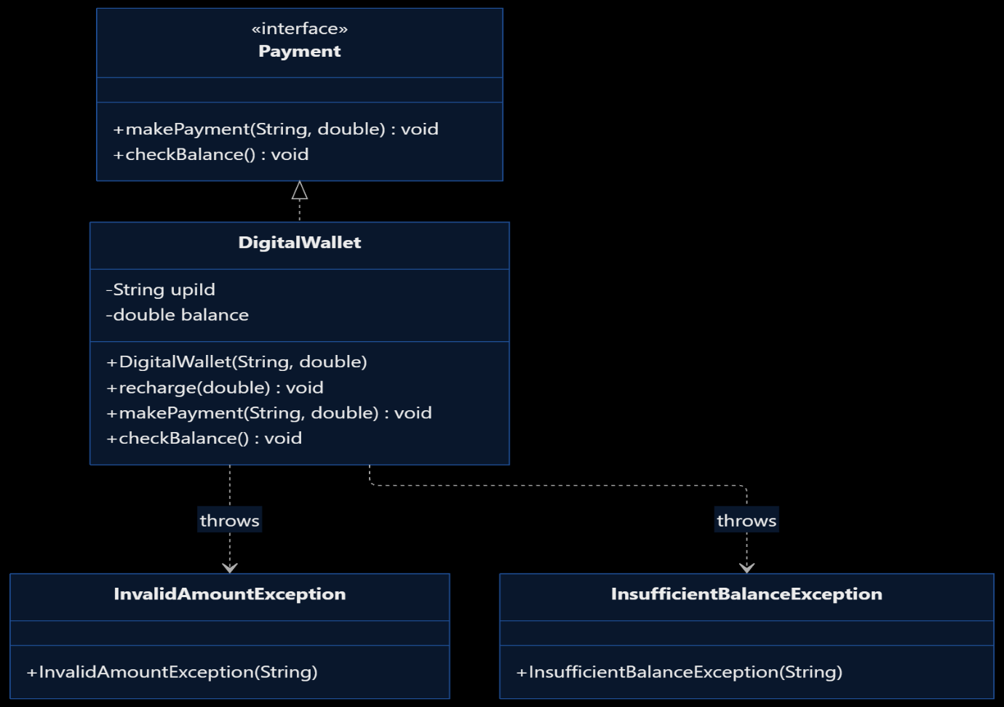
5. Source Code
Save the file as UPIWalletSystem.java.

import java.util.Scanner;

interface Payment {
void makePayment(String receiverUPI, double amount)
throws InsufficientBalanceException,
InvalidAmountException;

void checkBalance();
}

class InvalidAmountException extends Exception {
InvalidAmountException(String message) {
super(message);
}
}

class InsufficientBalanceException extends Exception {
InsufficientBalanceException(String message) {
super(message);
}
}

class DigitalWallet implements Payment {
private String upiId;
private double balance;

DigitalWallet(String upiId, double balance)
throws InvalidAmountException {
if (upiId == null || !upiId.matches(
"[A-Za-z0-9._-]+@[A-Za-z0-9]+")) {
throw new IllegalArgumentException(
"Invalid UPI ID.");
}

if (!Double.isFinite(balance) || balance < 0) {
throw new InvalidAmountException(
"Invalid initial balance.");
}

this.upiId = upiId;
this.balance = balance;
}

public void recharge(double amount)
throws InvalidAmountException {
if (!Double.isFinite(amount) || amount <= 0) {
throw new InvalidAmountException(
"Recharge amount must be positive.");
}

if (!Double.isFinite(balance + amount)) {
throw new InvalidAmountException(
"Balance limit exceeded.");
}

balance += amount;
System.out.println("Wallet recharged successfully.");
}

@Override
public void makePayment(String receiverUPI, double amount)
throws InsufficientBalanceException,
InvalidAmountException {

if (receiverUPI == null || !receiverUPI.matches(
"[A-Za-z0-9._-]+@[A-Za-z0-9]+")) {
throw new IllegalArgumentException(
"Invalid receiver UPI ID.");
}

if (receiverUPI.equalsIgnoreCase(upiId)) {
throw new IllegalArgumentException(
"Cannot pay to your own UPI ID.");
}

if (!Double.isFinite(amount) || amount <= 0) {
throw new InvalidAmountException(
"Payment amount must be positive.");
}

if (amount > balance) {
throw new InsufficientBalanceException(
"Insufficient wallet balance.");
}

balance -= amount;
System.out.println("Payment successful!");
System.out.println("Receiver UPI: " + receiverUPI);
System.out.printf("Amount paid: Rs. %.2f%n", amount);
}

@Override
public void checkBalance() {
System.out.printf("Available balance: Rs. %.2f%n",
balance);
}
}

public class UPIWalletSystem {
public static void main(String[] args) {
Scanner sc = new Scanner(System.in);
DigitalWallet wallet;

try {
System.out.print("Enter your UPI ID: ");
String upiId = sc.nextLine();

wallet = new DigitalWallet(upiId, 1000.00);
System.out.println("Wallet created successfully.");
} catch (IllegalArgumentException |
InvalidAmountException e) {
System.out.println("Error: " + e.getMessage());
sc.close();
return;
}

int choice = -1;

do {
System.out.println("\n--- UPI DIGITAL WALLET ---");
System.out.println("1. Recharge Wallet");
System.out.println("2. Make Payment");
System.out.println("3. Check Balance");
System.out.println("0. Exit");
System.out.print("Enter choice: ");

try {
choice = Integer.parseInt(sc.nextLine());

switch (choice) {
case 1:
System.out.print("Enter recharge amount: ");
double recharge = Double.parseDouble(
sc.nextLine());
wallet.recharge(recharge);
break;

case 2:
System.out.print("Enter receiver UPI ID: ");
String receiver = sc.nextLine();

System.out.print("Enter payment amount: ");
double amount = Double.parseDouble(
sc.nextLine());

wallet.makePayment(receiver, amount);
break;

case 3:
wallet.checkBalance();
break;

case 0:
System.out.println("Thank you!");
break;

default:
System.out.println("Invalid menu choice.");
}

} catch (NumberFormatException e) {
System.out.println(
"Error: Please enter a valid number.");

} catch (InsufficientBalanceException |
InvalidAmountException |
IllegalArgumentException e) {
System.out.println("Error: " + e.getMessage());
}

} while (choice != 0);

sc.close();
}
}
6. Compilation and Execution Commands
javac UPIWalletSystem.java
java UPIWalletSystem
7. Sample Output Screen

Enter your UPI ID: user@upi
Wallet created successfully.

--- UPI DIGITAL WALLET ---
1. Recharge Wallet
2. Make Payment
3. Check Balance
0. Exit
Enter choice: 3
Available balance: Rs. 1000.00

--- UPI DIGITAL WALLET ---
Enter choice: 1
Enter recharge amount: 500
Wallet recharged successfully.

--- UPI DIGITAL WALLET ---
Enter choice: 2
Enter receiver UPI ID: friend@upi
Enter payment amount: 300
Payment successful!
Receiver UPI: friend@upi
Amount paid: Rs. 300.00

--- UPI DIGITAL WALLET ---
Enter choice: 3
Available balance: Rs. 1200.00

--- UPI DIGITAL WALLET ---
Enter choice: 2
Enter receiver UPI ID: friend@upi
Enter payment amount: 5000
Error: Insufficient wallet balance.

--- UPI DIGITAL WALLET ---
Enter choice: 0
Thank you!
8. output
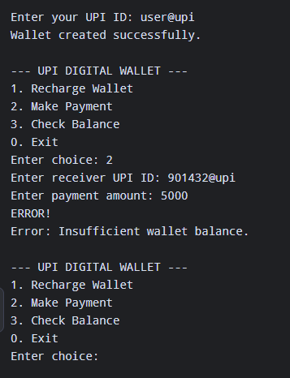
Result
Thus, the UPI Payment and Digital Wallet System was implemented successfully using Java. The program demonstrates interfaces, exception handling, user input validation, wallet recharge, payment processing, and balance checking.

